AI Based Learning Assistant

In this project we have created modules for faculties and students to sign up and login to application. After login faculty will perform below operations

1. Text Summary: Faculty can enter text or upload pdf or word file and then system will generate summary from input file or text
2. Subjective Question: using this module faculty can upload or enter text and then system will generated subjective question and answer from given text
3. Multiple Choice Question: using this module faculty can upload or enter text and then system will generated multiple choice question and answer from given text
4. View Marks: system will apply AI algorithm to evaluate students answers and then assigned marks and those marks can be view by faculty
5. Model Analysis: will display accuracy of model in terms of assigning marks to students answers evaluation which will compare students answers with correct answers generated by AI models

Students can login and perform below options

1. Generate Summary: can generate summary from word, pdf or text
2. Write Exam: can write subjective or multiple choice questions exam
3. View Marks: can view their marks obtained for each assignment.

SCREEN SHOTS

To run code install python 3.7.2 and then install all packages given in requirements.txt file and then double click on ‘run.bat’ file to start server and get below page.

Note: summary and question generations models are very heavy and it will take 3 minutes to start server and will take 6 minutes to generate question and answers in normal CPU system. In GPU it will run faster.

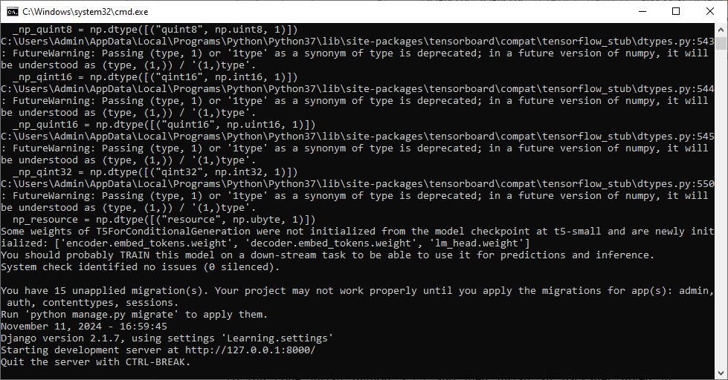

In above screen python server started and now open browser and enter URL as <http://127.0.0.1:8000/index.html> and then press enter button to get below page

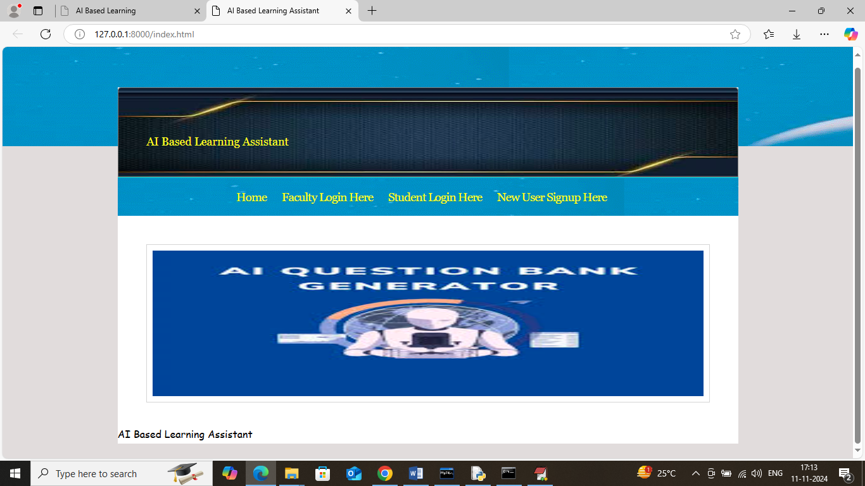

In above screen click on ‘New User Sign up Here’ link to get below page

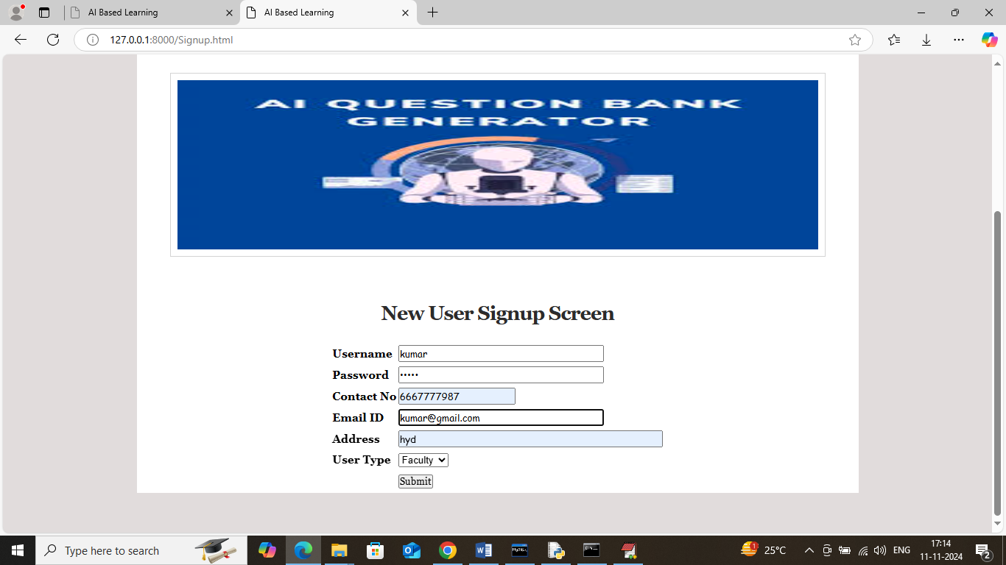

In above screen entering faculty sign up details and then press button to get below page

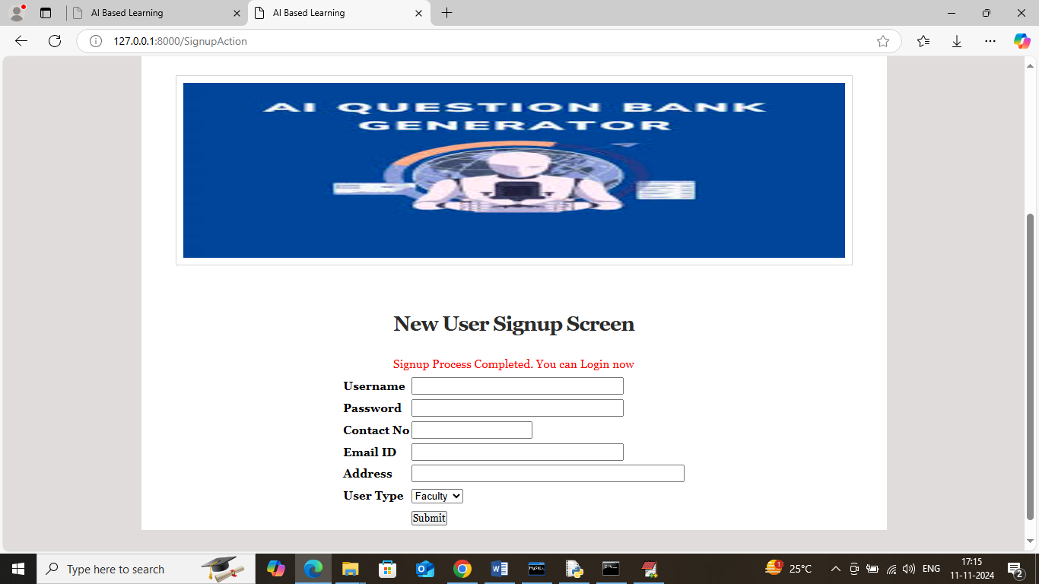

In above screen faculty sign up completed and similarly add student details

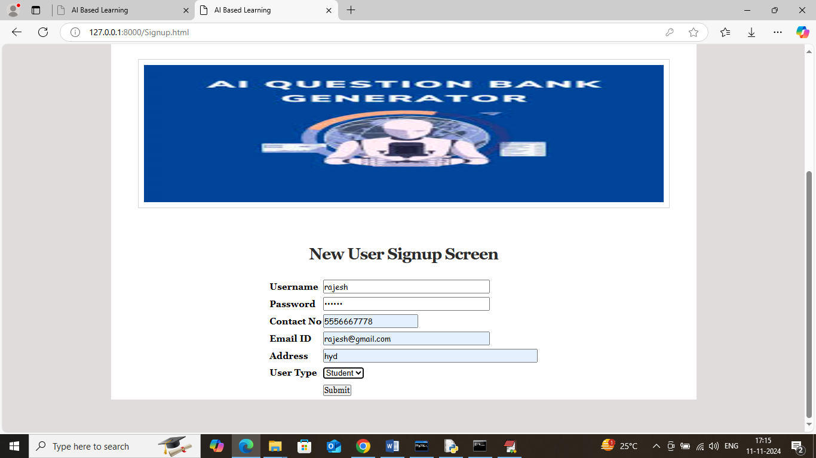

In above screen adding sign up details and then press button to get below page

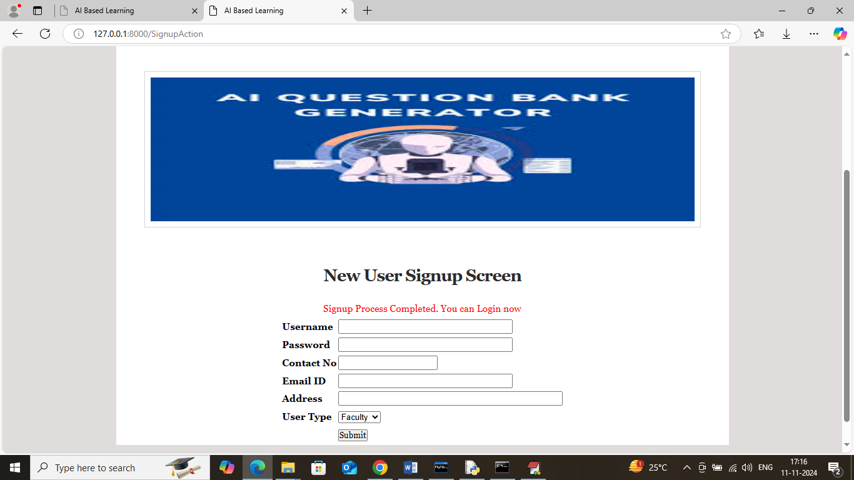

In above screen student sign up completed and now click on ‘Faculty Login’ link to get below page

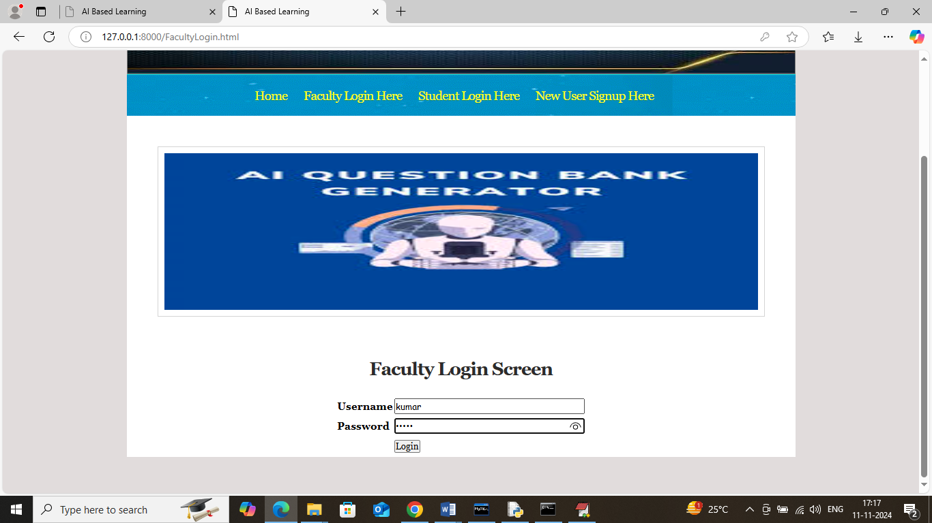

In above screen faculty is login and after login will get below page

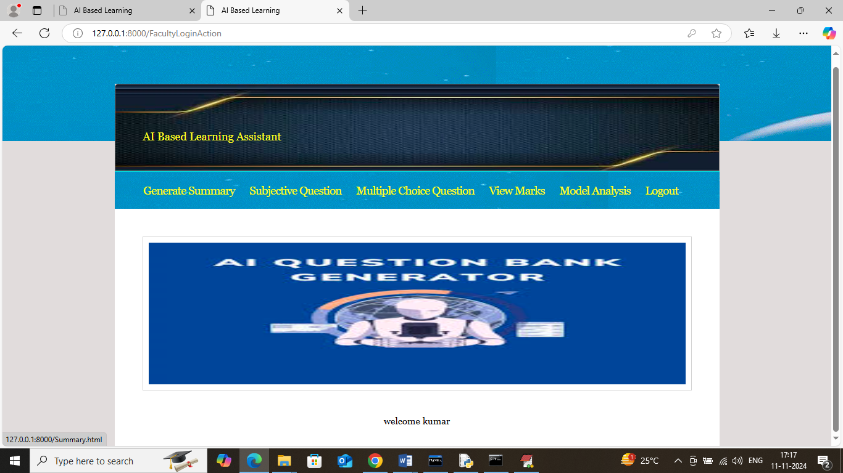

In above screen click on ‘Generated Summary’ link to get below page

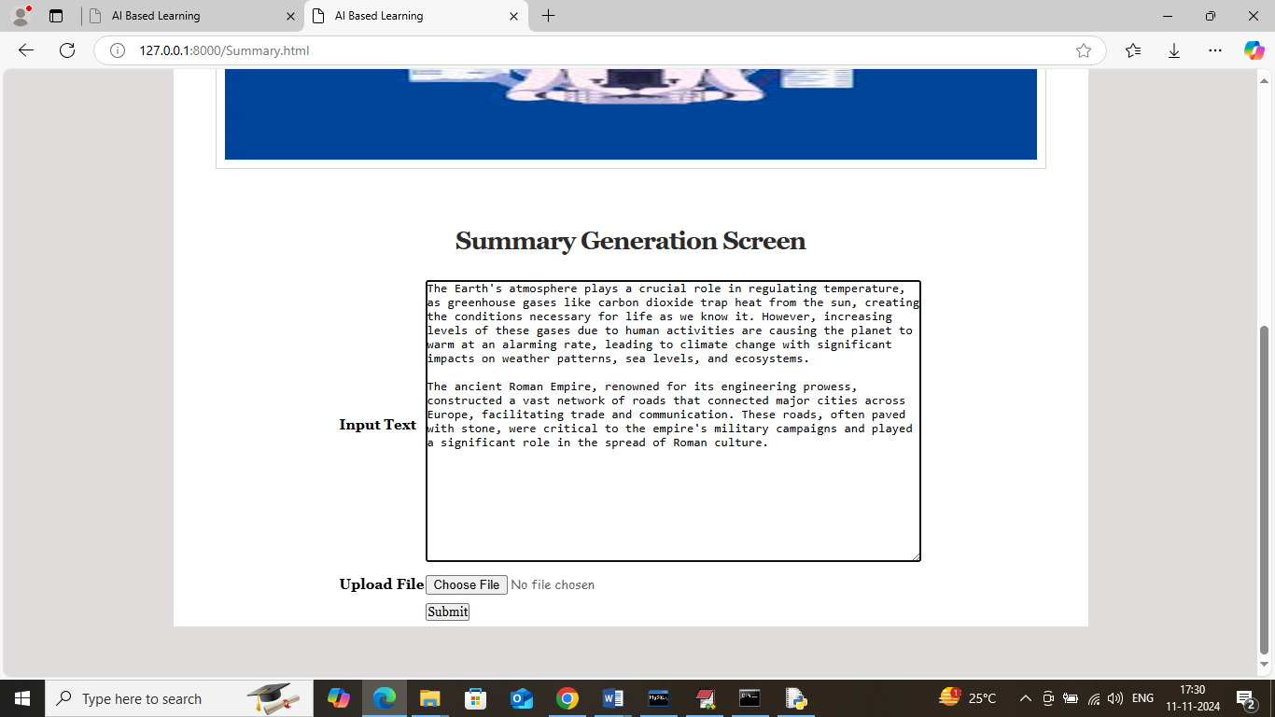

In above screen pasting some text and then click on button to get below page with summary

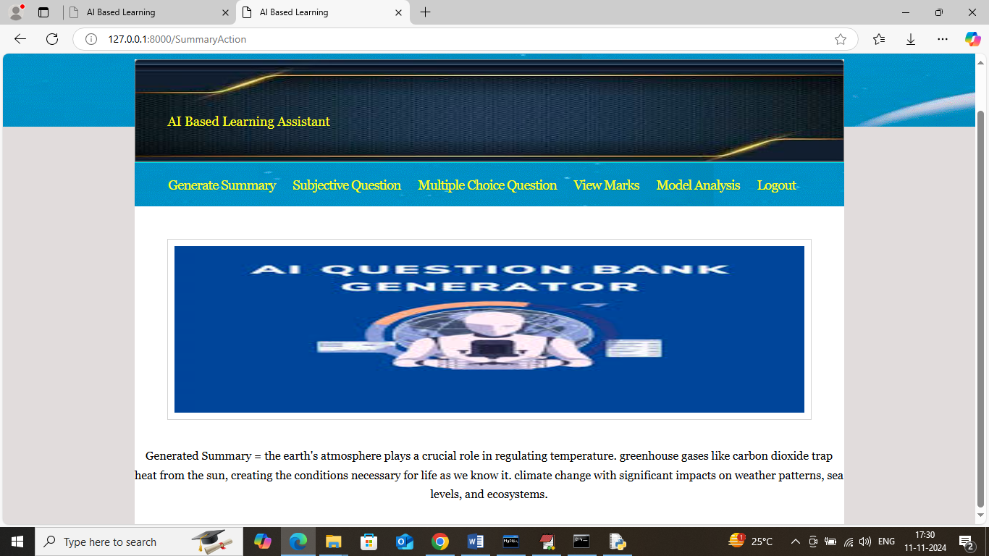

In above screen can see summary generated from given text and similarly you can upload and test small word or PDF file. Now click on ‘Subjective Question’ link to get below page

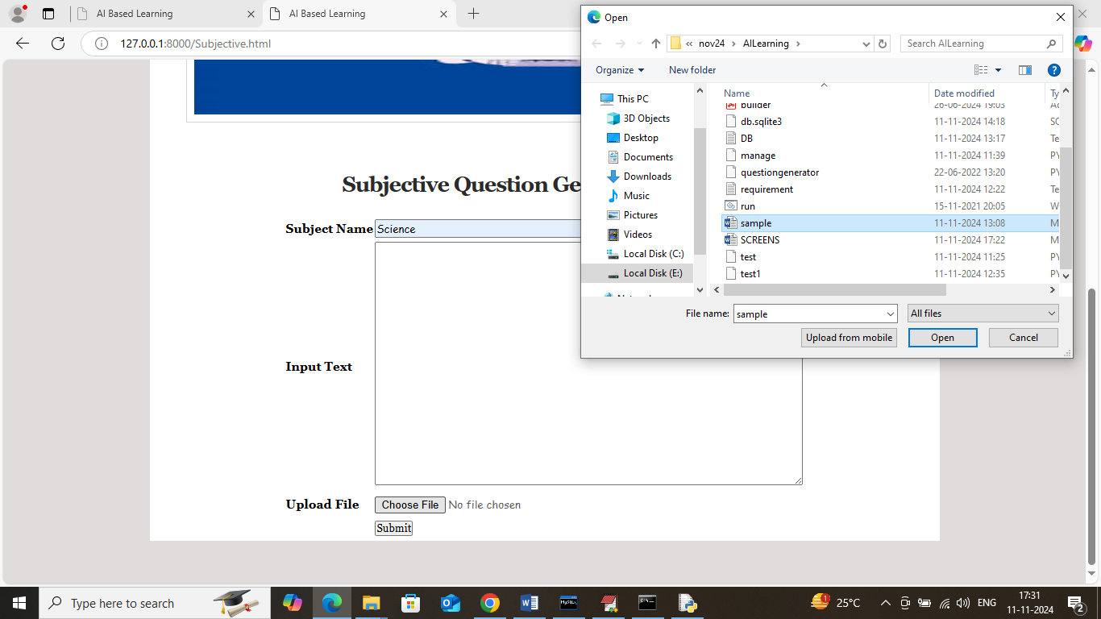

In above screen enter subject name and then upload word or PDF file or enter text in text area and then click button to get below generated questions and all this generated questions and answers will saved in database.

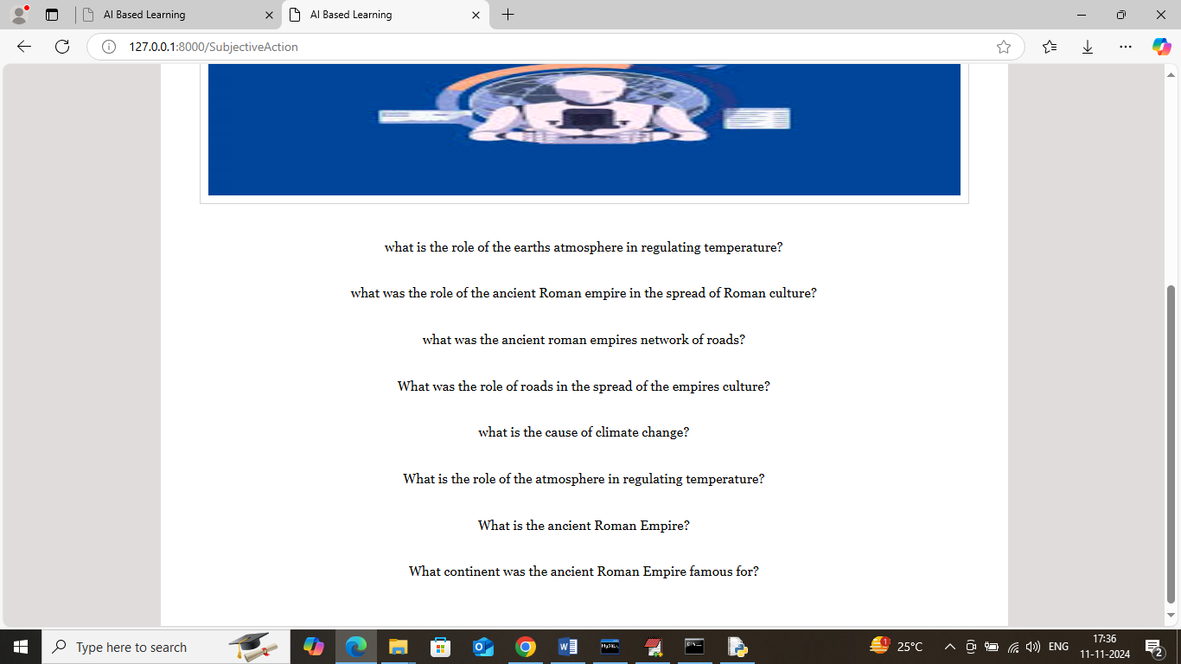

In above screen can see generated question from given text and can see both question and answers in database like below screen

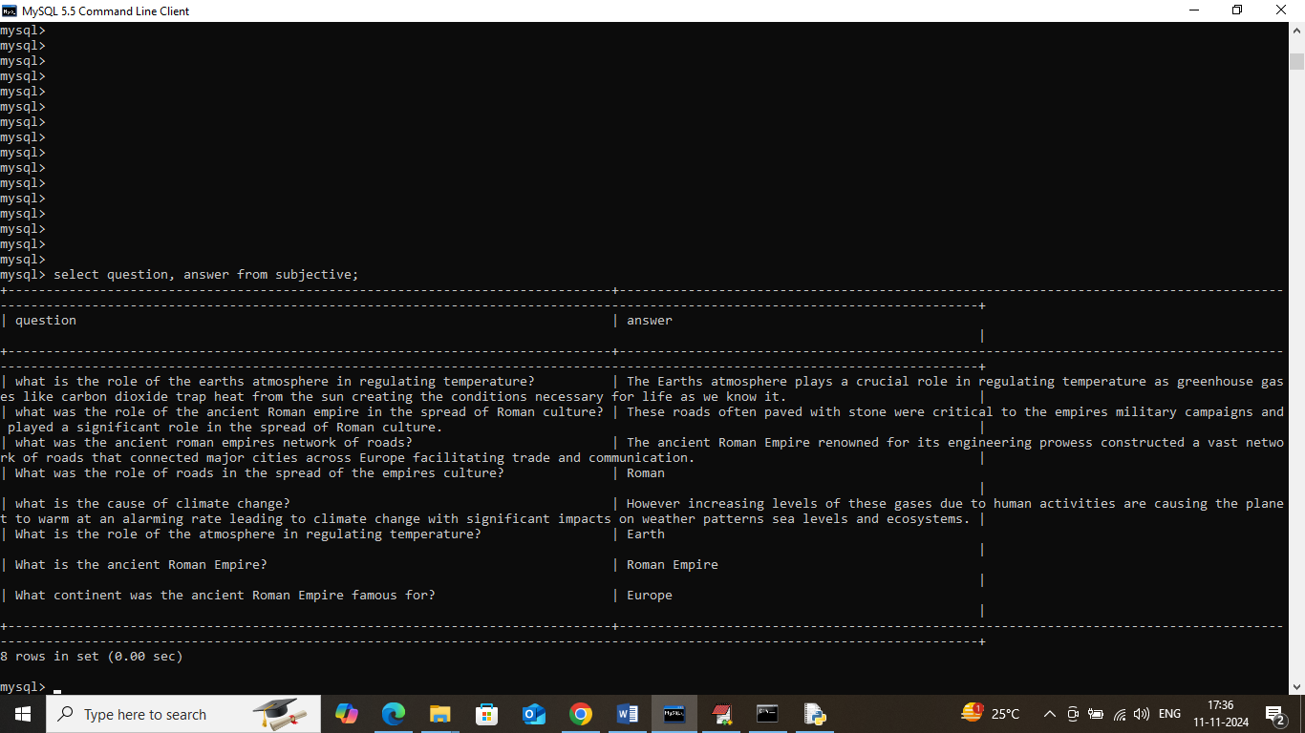

In above database screen can see generated question and answers from uploaded text and now in application click on ‘Multiple Choice Question’ link to get below page

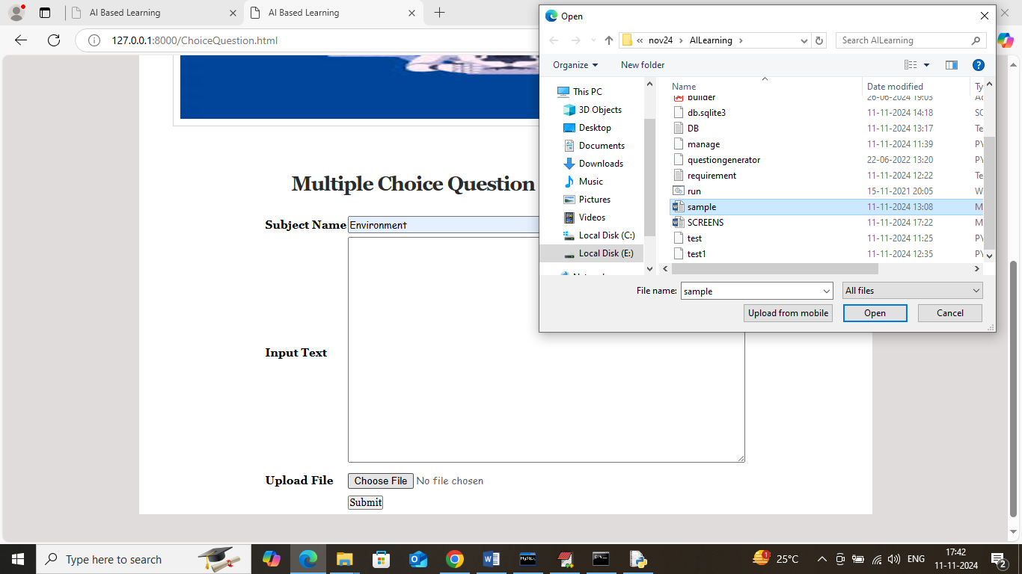

In above screen selecting and uploading word file and then click on ‘Submit’ button to generate multiple choice question and get below page

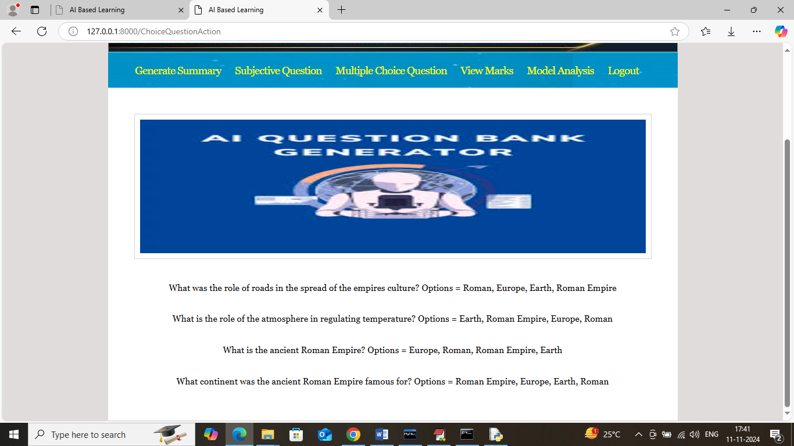

In above screen can see generated questions and their multiple choice options and this questions will saved in database so students can write exams. Now logout and login as students to write exam

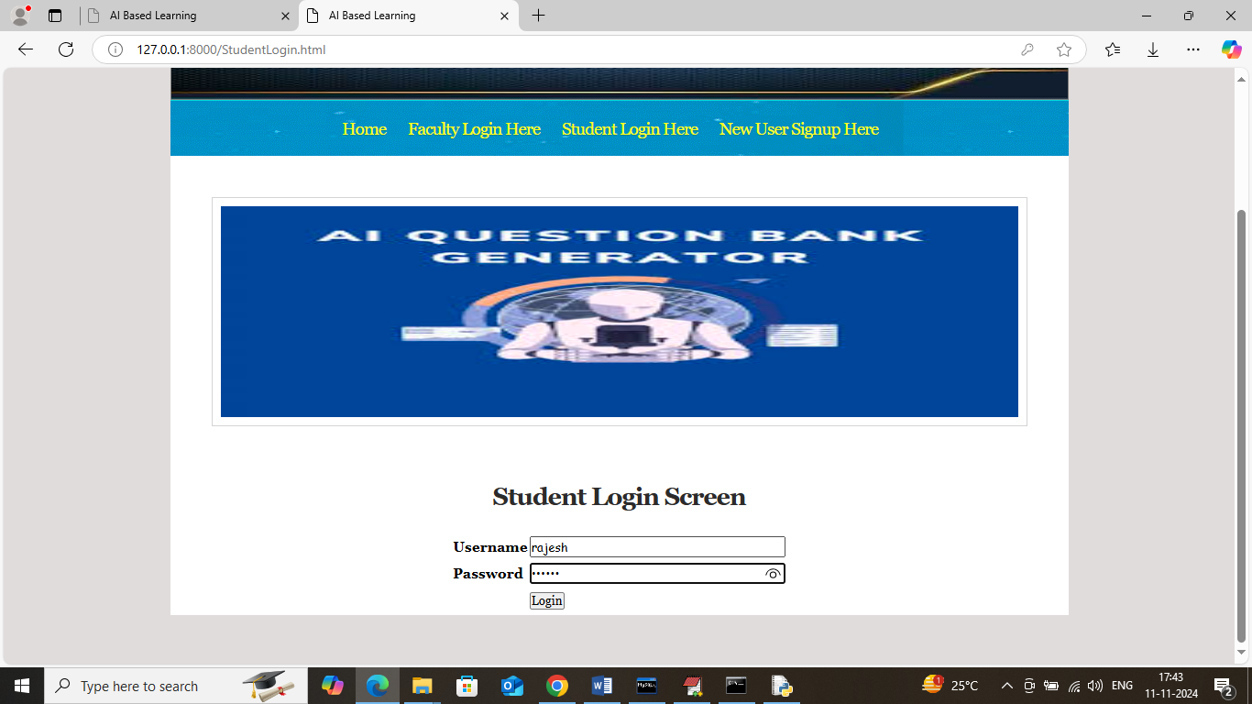

In above screen student is login and after login will get below page

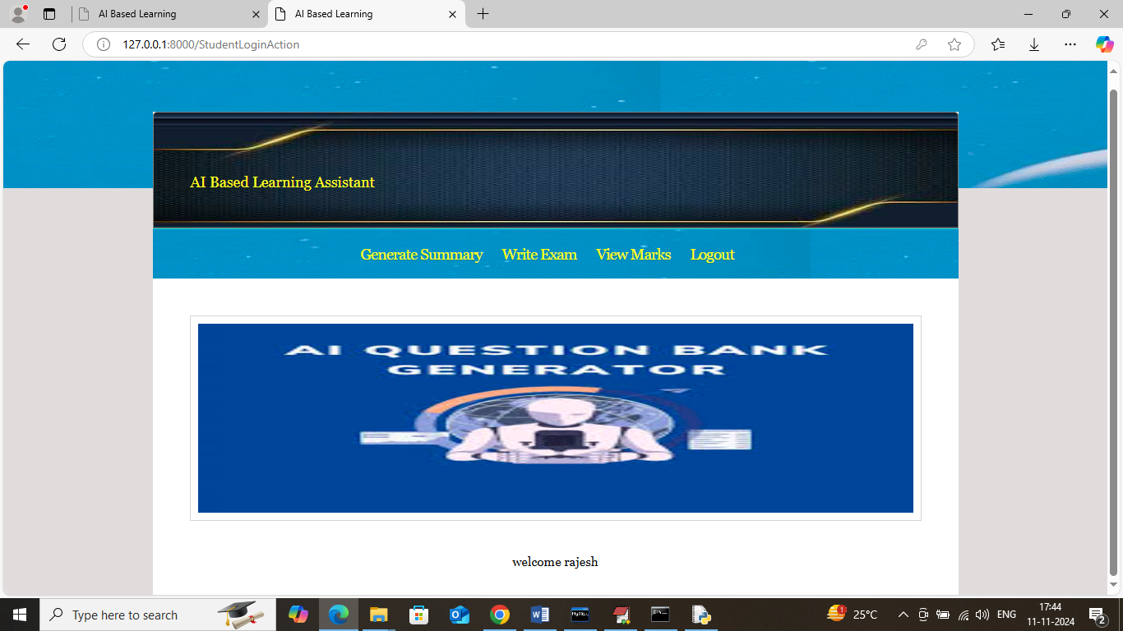

In above screen student can also generated summary for any text and now click on ‘Write Exam’ link to get below page.

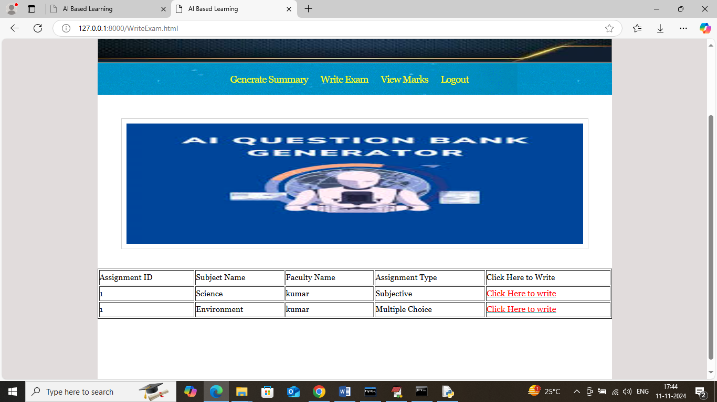

In above screen application will display number of subjective and multiple choice questions assignment and student can click on ‘Click Here’ desired link to get questions and write exam

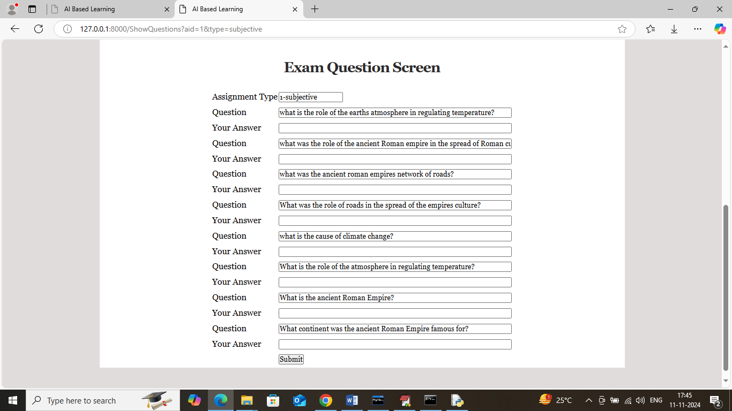

In above screen student can see all questions and write answers for each question

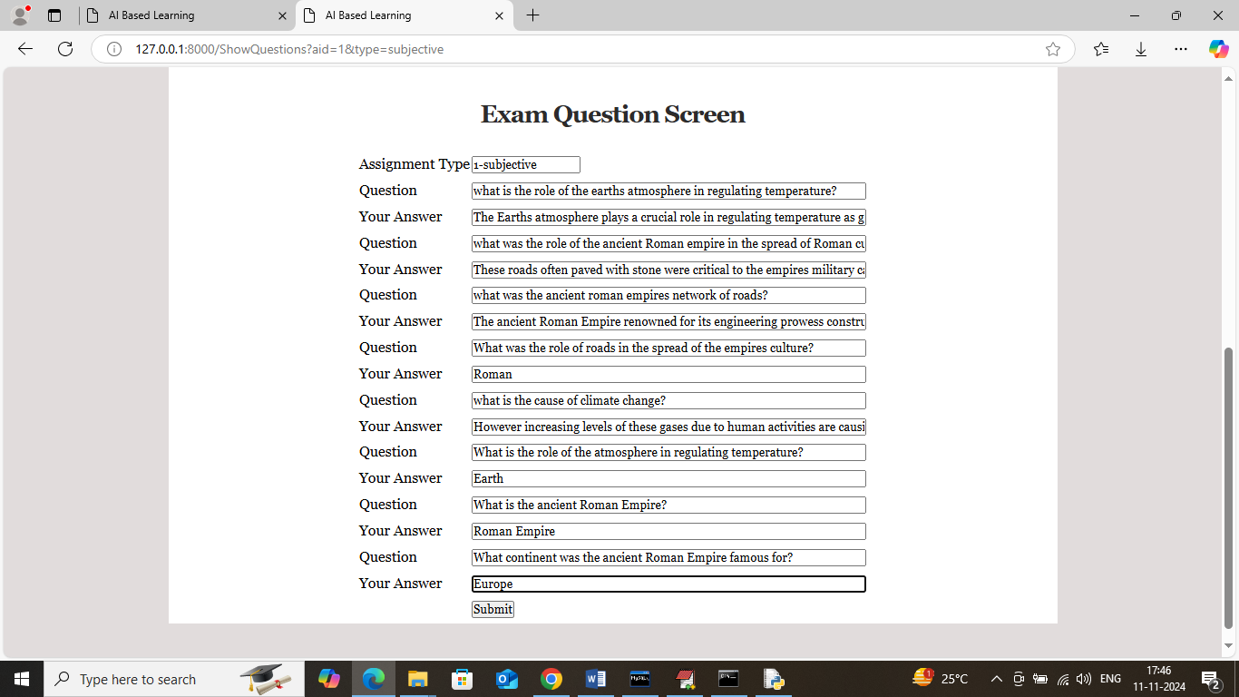

In above screen student will write answers for each question and then press button to allow ML algorithm to evaluate both database and students answers to get below score

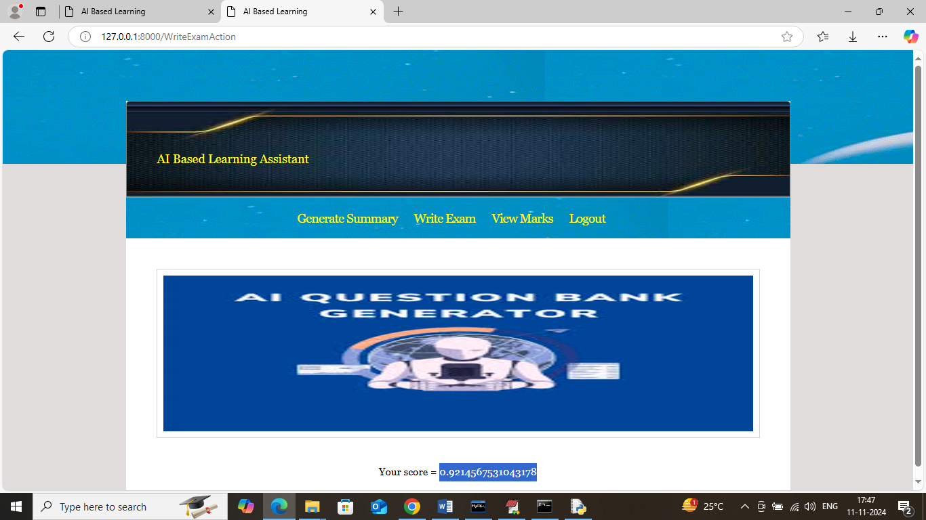

In above screen student got 92% score and similarly students can select multiple choice option to write multiple choice exam

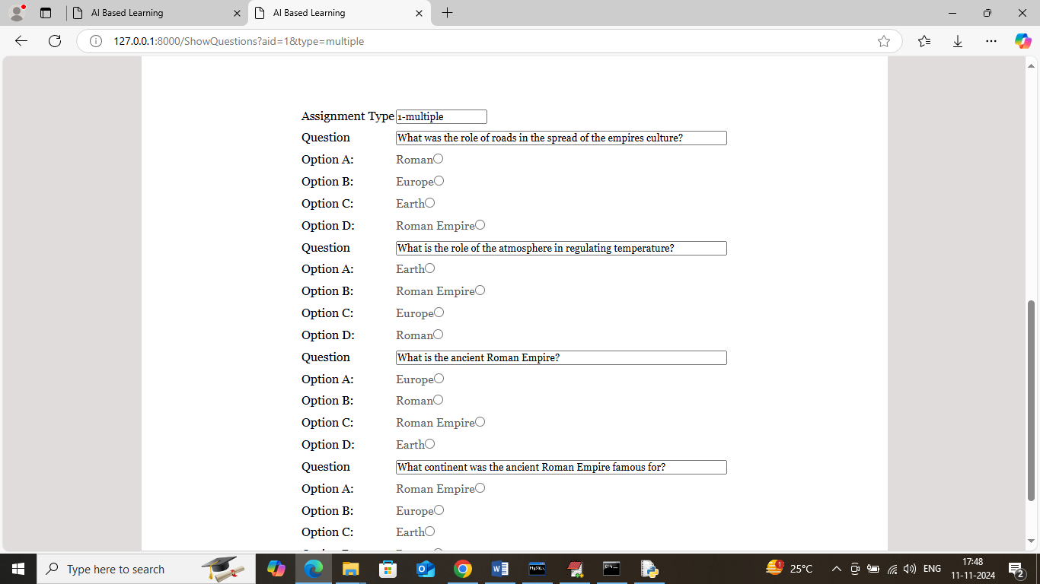

In above screen students can see all questions along with answers and can write exam to get score and now click on ‘View Marks’ link to get below page

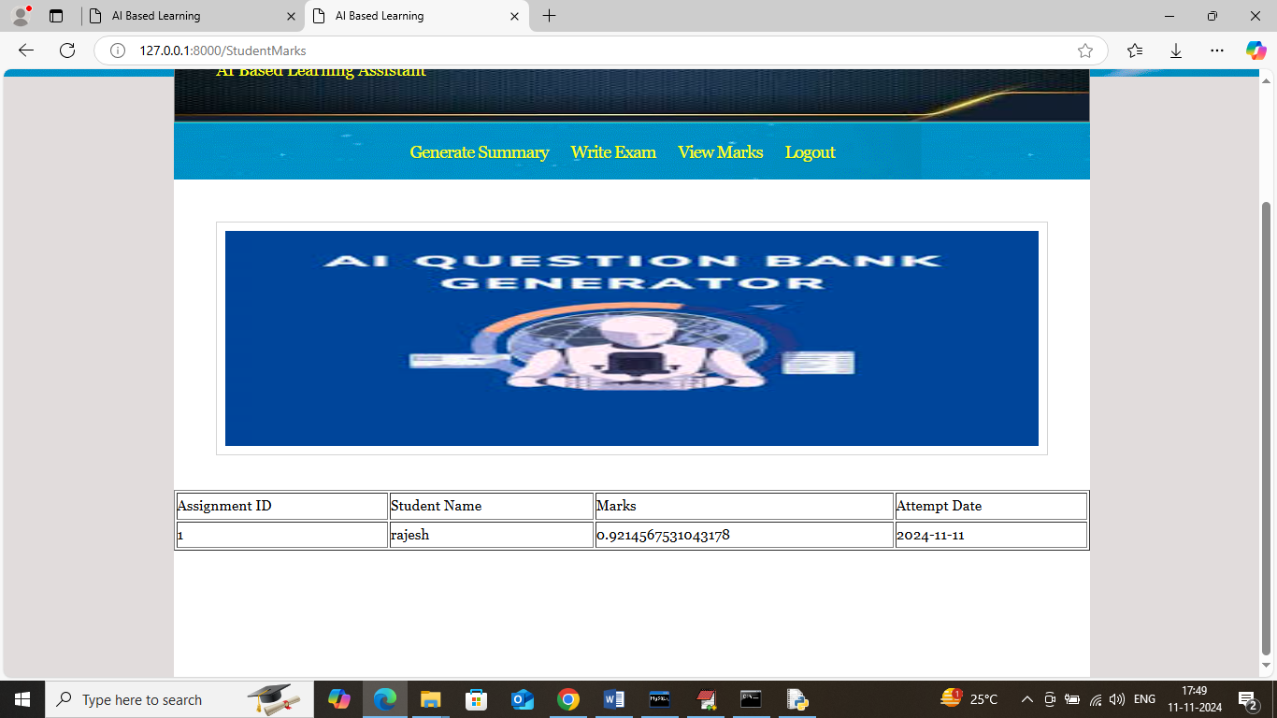

In above screen students can see marks obtained in given assignment ID and now logout and login as faculty to perform model analysis

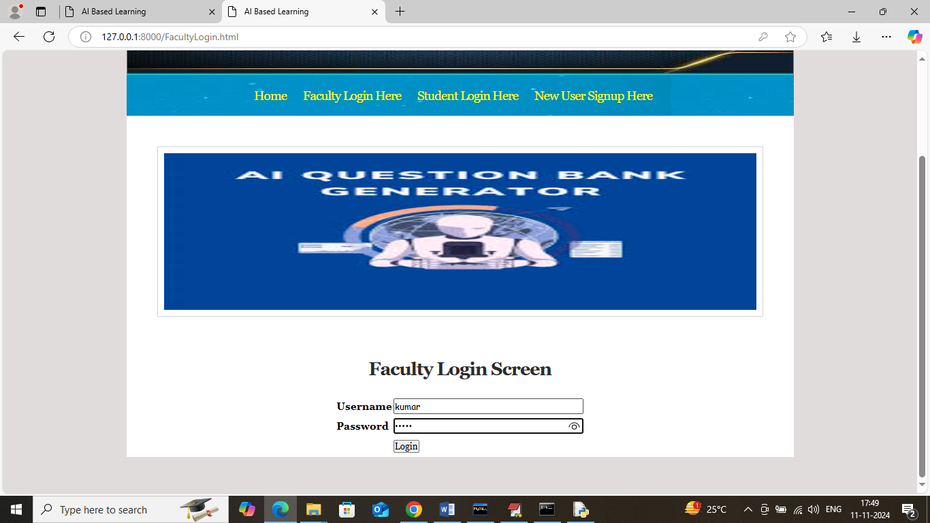

In above screen faculty is login and after login will get below page

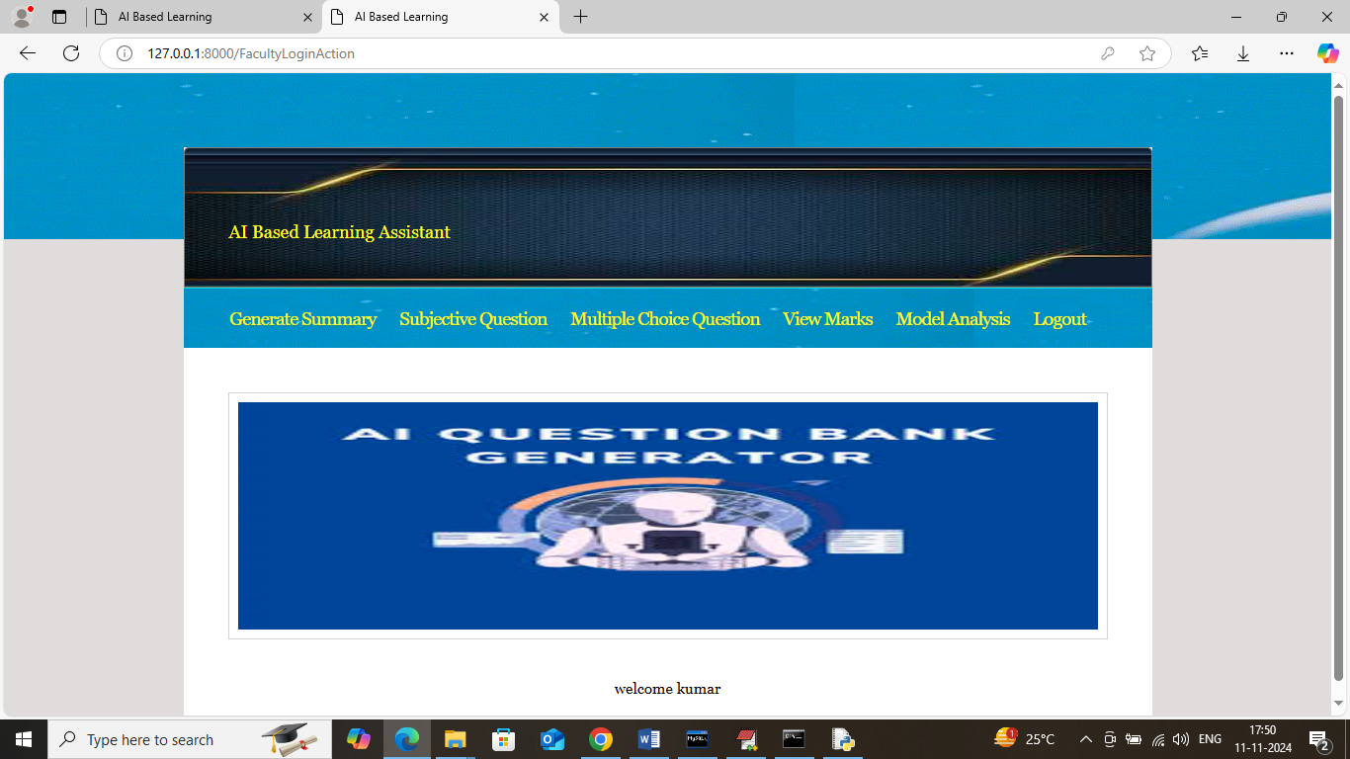

In above screen click on ‘View Marks’ link to view all assignments marks and get below page

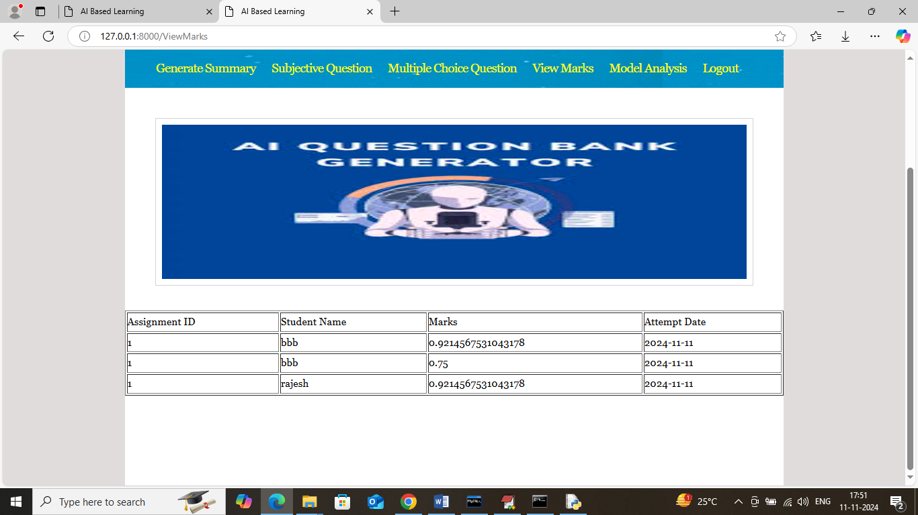

In above screen faculty can view marks for all students assignment and now click on ‘Model analysis’ link to get below page

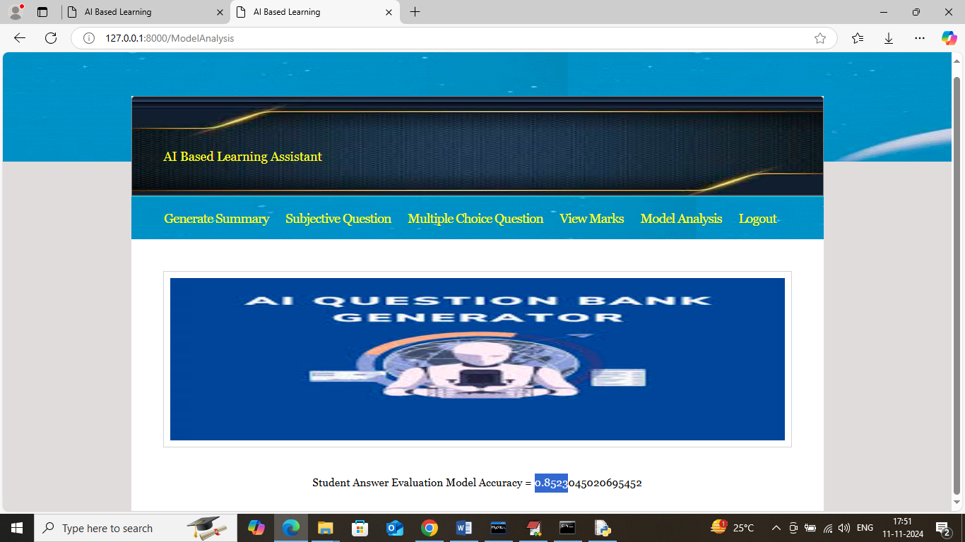

In above screen model got 85% accuracy to evaluate all student’s answers.

Similarly by following above screens you can generate automatic questions and answers and students can write exams